Space and Shadows
Writing  (choose 4 to complete)  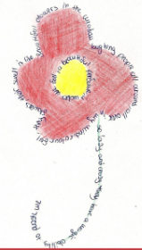  - Story - Imagine you are travelling into Space. Write an adventure story about aliens, new planets etc.  - Descriptive paragraph – Write a paragraph to describe an object or item which can only be used with feel and not looking at it.  - Instructions – Write instructions on how to build a robot that can take over the Universe.  - Poem - Write an acrostic poem using the word SHADOW.  - Research a famous lighthouse or planet -Write a paragraph about it.  - Write a short play to use with the shadow puppet, creating characters and their names. Remember to include description. | Maths  Complete the Whiterose maths booklet | 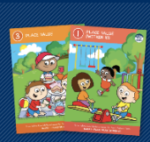
 | Spelling Frame  Practise each week  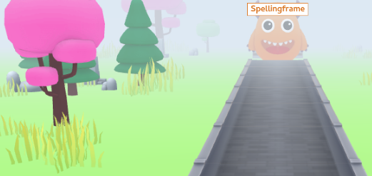 | TT Rockstars  Practise each week  
Angelou Class Homework Spring 4  Return all work by 22nd March | Reading  Read 4 times each week to an adult for at least 15mins and remember to get the adult that listens to you read to sign your home/school diary.
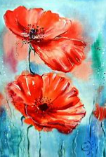  Creative (choose 1)  * Create a 3-d model of a robot. * Paint a picture of Space.  * Design a shadow puppet.  * Create a collage of an alien. |  |  | 