Enough for Everyone
Writing  (complete 3)  - Leaflet: Saving our planet.  - Write a report: Recycling.  - Letter: To Mrs Stanley-Wainwright suggesting things we can do in school to help save our planet.  - Poster: reduce electricity, gas and water usage. | Maths  Complete the Arithmetic Booklet
 | Spelling Frame  Practice each week  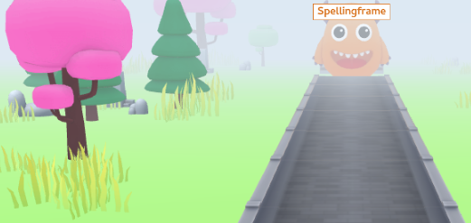 | TT Rockstars  Practice each week
Rashford Class Homework Spring 2  Return all work by 22nd March. | Reading  Read 4 times each week to an adult for at least 15mins and remember to get the adult that listens to you read to sign your home/school diary.
Creative
These are just ideas – be as creative as you can
* sketch/paint a beautiful place * 3-d model using ALL recycled materials * Plant some seeds

Enough for Everyone

