Our Changing World
Writing   (choose 4 to complete)  - Poster: Identify the risks and create a safety poster about Coastal Safety.  - Write a report: think about an area at home that has changed, (using a photograph as a stimulus if possible). Annotate a sketch of the place to show how it is now and what has changed and write a report.  - Leaflet: Write about how the area you live in has changed over time.  - Letter: pretend you are on holiday at the coast and write a letter home describing what it is like. | Maths  Complete the Arithmetic Booklet
 | Spelling Frame  Practice each week  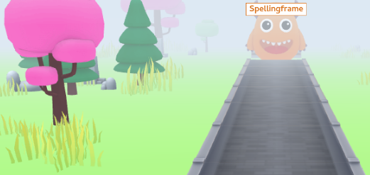 | TT Rockstars  Practice each week  
Rashford Class Homework Spring 1  Return all work by 9th February. | Reading  Read 4 times each week to an adult for at least 15mins and remember to get the adult that listens to you read to sign your home/school diary.
Creative  These are just ideas – be as creative as you can  * sketch the coast * Draw/paint/sketch a landscape * Create a 3d landscape  * create the water cycle |  |  | 
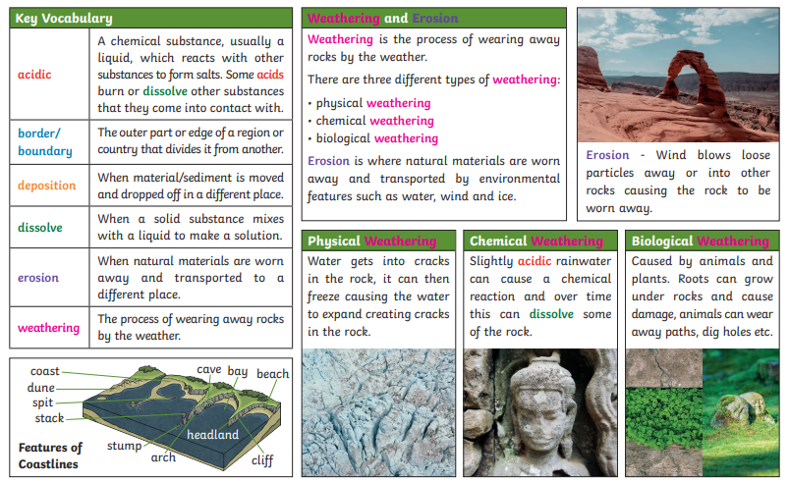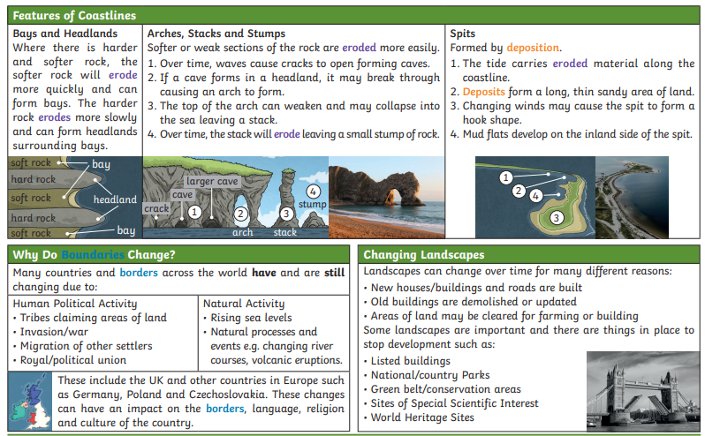
Our Changing World

