80th ANNIVERSARY

COMMEMORATIONS

of

**The Loss of**

*WELLINGTON BOMBER W5795*

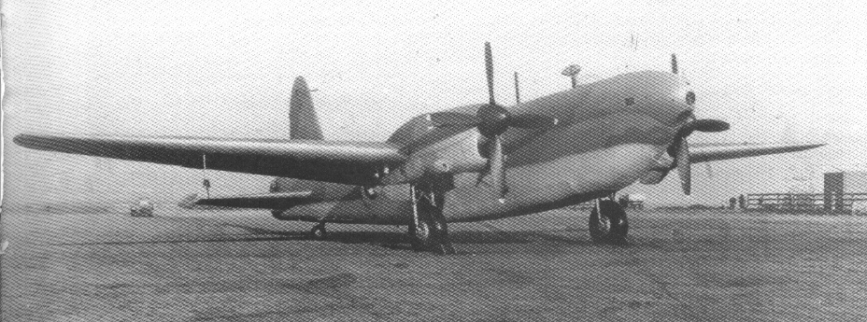

**Saturday 2nd July 2022**

**11:00** **Service of Remembrance**

St Andrews Churchyard, Stanley

12:30 **Carnival Procession** from Dale Road

to Playing Field off Coronation Road

*(Derby Rd & Station Rd Closure)*

**13:30** **Stanley Gala** Official Opening on the

Village Recreation Ground

**14:31** **Flypast of WWII BoBMF Lancaster**

In Tribute to the Crew of W5795

**Field Parking Station Rd between Church and Playing Field Donation £1 to Charity**



