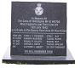

80th ANNIVERSARY

ANNIVERSARY SERVICE

of

**The Loss of**

*WELLINGTON BOMBER W5795*

**St. Andrew's Churchyard**

**Stanley Village,**

**Derbyshire, DE7 6FB**

2nd July 2022 at 11am

**BofBMF Flyover Salute by WWII Lancaster Over Stanley Playing Field. Scheduled for 14:31 Hrs**



**EIGHTY YEARS have slipped quickly by,**

**No tears now shed by tortured eye,**

**But memories still recall these men,**

**Who cannot come to us again.**

**Their youth was spent,**

**Their manhood lost,**

**Our peace was gained,**

**At such a cost.**

**God grant that we may live in peace,**

**And see the day,**

**When All Wars will cease. Amen**

**© Terry Hall, 69 Station Rd, Stanley, DE7 6FB**

**MOSVT Update 02 June 2022**



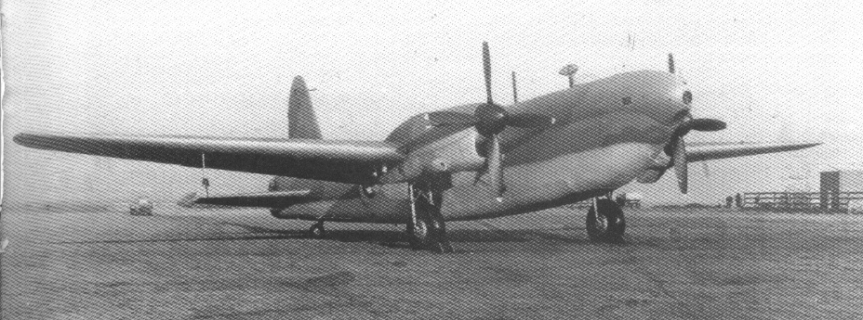

**St. Andrew's Parish Church will be open**

**from 10:30am-12pm for Sanctuary**

**and Prayer.**



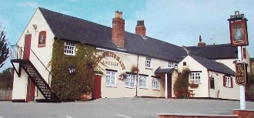

**SOCIALISE AFTER THE SERVICE**

**On completion of the Service you are invited**

**to informally socialise at the WHITE HART PH**

**Stanley Village 🕿 01158 372940 Open at 10:30**

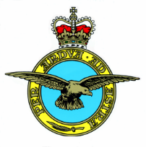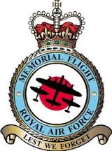

**MOSVT** thanks the Stanley Village Hall

and many Villagers who support the

Service and make the **visiting relatives**

of the Crew of the Stanley Bomber so welcome.



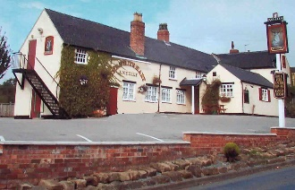



**Printing of this Order of Service**

**was kindly Sponsored by**

**Erewash Borough Council**

**The Trustee of MOSVT**

**Thank all who Support this Annual Service of Remembrance**

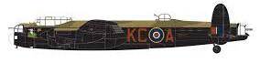

### **THE WELCOME AND INTRODUCTION: Terry Hall MOSVT**

***Minister****:* ***Rev Jan Hutchinson***. We meet here today to remember the crew of Wellington Bomber W5795 who died on active service when their plane crashed to the South of the village of Stanley on the 12th July 1942.

Let us remember the families and friends of those who served and who waited anxiously for their return.

### **.**

***All say:*** *Our Father, who art in Heaven, hallowed be thy name;*

*thy kingdom come; thy will be done; on earth as it is in Heaven,*

*Give us this day our daily bread. And forgive us our trespasses,*

*as we forgive those who trespass against us.*

*And lead us not into temptation; but deliver us from evil.*

*For thine is the kingdom, the power and the glory, for ever and ever****. Amen***

***Standards will come to the carry, Parade come to Attention***

***The Royal Air Force Flag Will Be Half Masted***

### **THE ACT OF REMEMBRANCE**

***Minister:*** Let us remember before God, and commend to his sure keeping, those who have died for their country in war and peace;

those whom we knew, and those whose memory we treasure,

and all who lived and died in the service of their country and mankind.

*Names of fallen who are commemorated on the memorial**shall be read by:*

***Terry Hall Memories of Stanley Villige Trustee (MOSVT)***

***As each name is read out, a family Member of the crew will lay a***

***named Poppy Cross remembering each of the crew of W5795.***

***Squadron Leader Cyril Lancelot Fellowes Colmore Royal Air Force***

***Pilot Officer Kenneth Radford RAF Volunteer Reserve***

***Flight Sergeant Ronald Potts Gillott RAF Volunteer Reserve***

***Flight Sergeant Arthur James Smith DFM Royal Air Force***

***Mr Clifford Abbott Civilian Technical Test Observer***

***ALL:*****May They Rest In Peace.**

***'Pipe Lament' To Be Piped Whilst Wreaths Are Laid***

### **WREATHS & CROSSES WILL BE LAID.**

*Mrs Hillary Eddleston Daughter of Pilot Officer Radford RAF*

*Daughters of Mrs Betty Ackrill, Sister of Flt Lt R.P. Gillott RAF*

*The Mayor of Erewash Borough Council Cllr John Sewell*

*Derbyshire County Council – Cllr Carol Hart*

*Erewash Borough Cllrs – Abey Stevenson & Alan Summerfield*

*Stanley Parish Council Representative, RAF Association (Erewash)*

*Ilkeston RBL Branch, The Royal British Legion Riders Branch MOSVT*

*Mr Kevin Horsnall in memory of George, First on the Crash Scene 1942*

***Any Further Wreaths or Crosses***

##### ***The Mayor of Erewash – Cllr John Sewell***

In friendship and service to one to another, we are pledged to

keep alive the memory of those of all nations, who died in

the Royal Navy, our Army & Royal Air Force.

In their name we give ourselves to this noble cause.

**ALL: *Proudly and Thankfully We Will Remember Them.***

##### **THE EXHORTATION**

##### **Given by** ***The Chairman of*** ***the RBL Ilkeston – Mr Arthur Norman***

They shall grow not old, as we that are left grow old, age shall not weary them, nor the years condemn. At the going down of the sun and in the morning, we will remember them.

# ALL: We Will Remember Them

### **THE LAST POST** - **One Minute Silence**

##### **REVEILLE**

##### **THE KOHIMA EPITAPH**

##### ***Recited by Representative of RAFA Erewash Chair,***

When you go home, tell them of us and say,

For your tomorrow, we gave our today

***RAF Flag Re-Hoisted - Parade will be stood at Ease***

##### **ACT OF COMMITMENT**

***Minister:*** Let us pledge ourselves anew to the service of God and our fellow men and women; that we may help, encourage and comfort others,

and support those working for the relief of the needy,

and for the peace and welfare of the nations.

***ALL: Lord God our Father, we pledge ourselves to serve you and all***

***mankind in the cause of peace, for the relief of want and suffering, and***

***for the praise of your Name. Guide us by your Spirit; give us wisdom;***

***give us courage; give us hope; and keep us faithful now and always.***

***Through Jesus Christ our Lord. AMEN.***

##### **THE BLESSING**

***Minister****:* God grant to the living, grace; to the departed, rest;

to the Church, the Queen, the Commonwealth

and all mankind, peace and concord;

and to us and all his servants, life everlasting. **AMEN.**

***'Wings' Will Be Piped Whilst People Disperse***







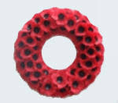Poppy Cross

