[](https://www.google.co.uk/url?sa=i&rct=j&q=&esrc=s&source=images&cd=&ved=2ahUKEwii8rOZ3PPiAhVZBGMBHUmxAzQQjRx6BAgBEAU&url=https%3A%2F%2Fwww.justgiving.com%2Fclas43&psig=AOvVaw3-VxGC5T-jhHECFbaIA9EX&ust=1560970502684540)[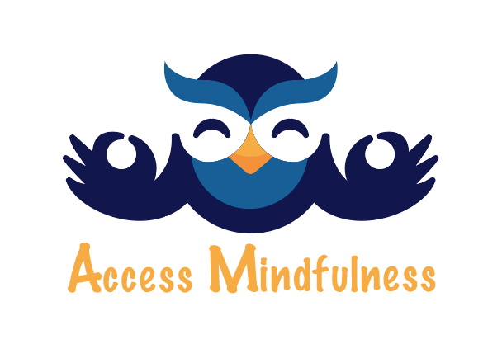](https://www.google.co.uk/url?sa=i&rct=j&q=&esrc=s&source=images&cd=&cad=rja&uact=8&ved=2ahUKEwjGs4v73vPiAhULNBQKHUDACqwQjRx6BAgBEAU&url=%2Furl%3Fsa%3Di%26rct%3Dj%26q%3D%26esrc%3Ds%26source%3Dimages%26cd%3D%26ved%3D%26url%3Dhttp%253A%252F%252Faccessmindfulness.org%252F%26psig%3DAOvVaw1EknTRYS6lqCYP9b5FFSej%26ust%3D1560971695475538&psig=AOvVaw1EknTRYS6lqCYP9b5FFSej&ust=1560971695475538)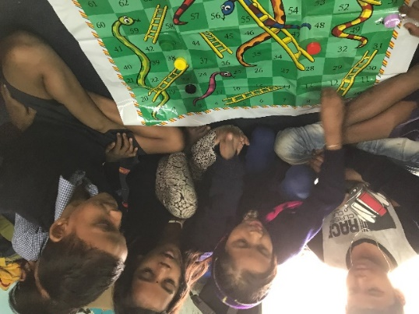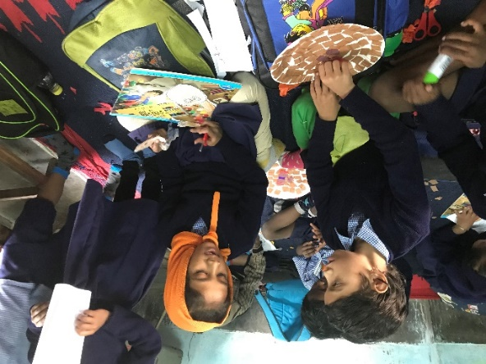[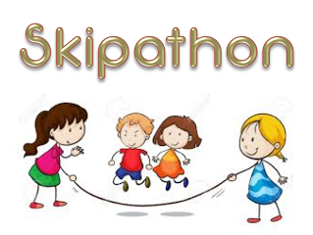](https://www.google.co.uk/url?sa=i&rct=j&q=&esrc=s&source=images&cd=&ved=2ahUKEwjtp8652vPiAhUvBGMBHQHmAMIQjRx6BAgBEAU&url=http%3A%2F%2Fwww.crehanans.ie%2Fnews%2Funtitledpost-1&psig=AOvVaw3-VxGC5T-jhHECFbaIA9EX&ust=1560970502684540)

**Mindfulness**

**Sponsor Skipathon**

**Let’s raise lots for**

**Dum Dum**

**Sponsored Skipathon and Wellbeing Afternoon – Thursday 27th June**

**Please help raise funds for Dum Dum.**

**Skipathon Sponsorship Form**

**Name –**

**Total number of skips -**

|  |  |  |  |
| --- | --- | --- | --- |
| **Name:** | **Amount per skip** | **Donation** | **Total** |
| e.g. Stanley Owl | 50p | ------------ | 25 skips = £12.50 |
| e.g. Wise Owl | -------------------- | £10.00 | £10.00 |
|  |  |  |  |
|  |  |  |  |
|  |  |  |  |
|  |  |  |  |
|  |  |  |  |
|  |  |  |  |
|  |  |  |  |
|  |  |  |  |
|  |  |  |  |
|  |  |  |  |
|  |  |  |  |
|  |  |  |  |
|  |  |  |  |
|  |  |  |  |
|  |  |  |  |
|  |  |  |  |
|  |  |  |  |
|  |  |  |  |
|  |  |  |  |