Derbyshire Submariners
ARMISTICE DAY SOCIAL MEET
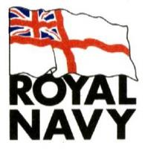
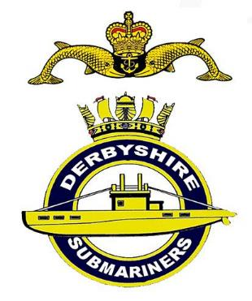
THE JUBILEE CLUB
155 Chaddesden Lane,
Chaddesden
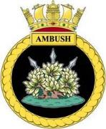
Derby DE21 6LJ

SATURDAY
11 November 2023
11:30hrs – 14:00hrs

Coffee & Full Bar Available
All Welcome

To meet in convivial
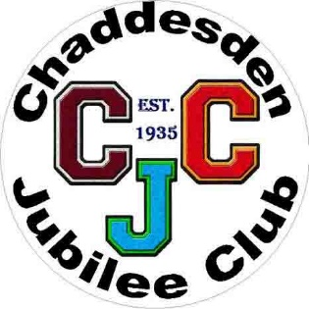
surroundings after the
Armistice Soldiers Corner
Annual Remembrance Service

We have invited Mayor of Derby,

and crew members of HMS/M Ambush

Derby's adopted Warship

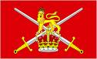
Unveiling of Ceremonial Display of Submarine
Dolphins of S/M' Plaques, who the CJC have hosted.

It is planned the Main Access Gates to the cemetery
will be open but access can be gained via the gate
and car park opposite Reginald Road

The Services in Nottingham Road Cemetery commence 10am with two graveside Homages from the Main Entrance, thence convoy of cars around to Soldiers Corner ending with the main 11am Service & Wreath laying.

To help DS cover costs of Social & Wreaths etc, any donation of a Raffle Prize would be appreciated on the day please or beforehand if able preferably of portable prizes, such as Bottles or Drink, Chocs etc.

An opportunity for ALL to Socialise and enjoy
Congenial Serving and Ex Services Company

