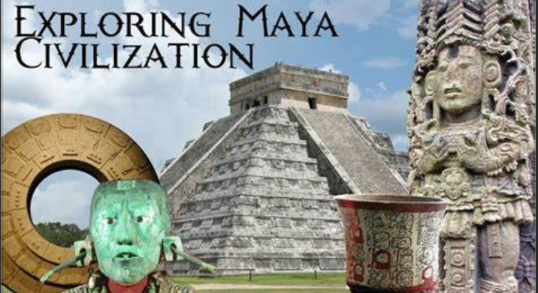 Maya Civilisation
Writing   (choose 4 to complete)  - Fact file – create a fact file about a Mayan god.  - Descriptive paragraph – write a paragraph to describe a character for a Mayan myth.  - Report – Write a report about visiting Mayan times.  - Poem - Write a poem linked to Mayan civilisation.  - Diary Entry - Write a diary entry as a Mayan.  - Fact file – choose an area of Mayan civilisation and write about it. | Maths  Complete the Whiterose maths booklet | 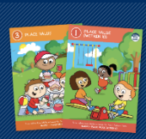
 | Spelling Frame  Practice each week   | TT Rockstars  Practice each week  
Rashford Class Homework Autumn 2  Return all work by 15th December | Reading  Read 4 times each week to an adult for at least 15mins and remember to get the adult that listens to you read to sign your home/school diary.
Creative (choose 1)  * Create your own stone-carved art * Sketch a picture of a Mayan artefact  * Create a 3d Mayan temple * Make a Mayan mask |  |  | 