My Book Review

Title: Knock Three Times
Series Title: The Wizards of Once
Author: Cressida Cowell
Fiction or Non-fiction: Fiction

What was the book about?
This book is about three very different children. Wish is the thirteen-year-old daughter of Sychorax, Queen of the Warriors. Xar (pronounced Zar) is the thirteen-year-old second son to Encanzo, King of the Wizards. Then there is Bodkin thirteen-year-old assistant bodyguard to Wish. The Wizards and Warriors hate each other and are constantly fighting. This has allowed the witches to return. These three children have got some of the ingredients for a spell to get rid of witches. In the third book they get the last two ingredients (Droods tears from the Lake of Lost and four scales from the Nuckalavae) for the spell but in doing so accidently leave the Kingwitch unguarded. One of their faithful sprites Squeezjoos joins the Kingwitch because he got witch blood on him so, now the three heroes must save him before it is to late.

Who would you recommend this book to and why?
I would recommend this book to people of the age of seven or over who are interested in magic and mystery. This book has a very enchanting story line and I think that lots of people will enjoy it.

My favourite part in the book
My favourite part in this book is when Bodkin saved Wish and Xar from the Nuckalavae’s mouth because before that Bodkin had told Wish’s mother her location and he felt bad about it but when Wish and Xar were in danger he forgot all about that and he saved them. This is my favourite part because Bodkin thought that he could not be a hero but he overcame his doubt and saved his friends from being eaten by a monster.

Book cover
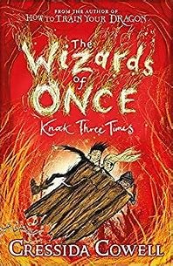

My Rating

